EXPERIMENT 10

Jai Prasadh

PHY 115L

INTRODUCTION

In this experiment I sought to continue learning about the interference and diffractive effects of light. Using a diffraction grating, I desired to measure the wavelength of a laser beam. I then set out to measure the diffraction angles for light incident both normally and non-normally to the grating. In analyzing these phenomena, I aimed to compare the observed diffraction pattern and angles to theoretical expectations. I also desired to observe and measure the Fresnel limit of diffraction from a semi-infinite wall to compare to the predicted behavior. Finally, I sought to observe and qualitatively describe the Fresnel diffraction from a solid disc and try to see the Arago spot for myself.

RESULTS

Diffraction from a Grating:

In this section, I set up the laser beam to shine normally through a diffraction grating of 600 grooves/mm. I first qualitatively observed the intensities of the diffraction pattern produced by eye, which should be noted to be a poor judge of intensity. For reference, I denote the center peak as 0 and the ones to the left of it as seen by someone facing the screen as -1, -2, etc. The -1 peak seemed substantially brighter than the +1 peak. The -1 peak was actually on par with or perhaps even brighter than the 0 peak. Both the -2 and +2 peaks were much dimmer and about equally bright. The grating appeared to be blazed since the maximum intensity seemed to be in the -1 peak, with all other peaks relatively dimmer.

Next, I measured the diffraction angles of each first and second order peak in the pattern by measuring the horizontal position x on the screen and comparing that to the grating-screen distance L. My results are as follow in table 1.

Table

|  |  |  |  |  |  |  |
| --- | --- | --- | --- | --- | --- | --- |
| Order | L (cm) | | x (cm) | | Observed θ (rad) | |
| -1 | 4.6 | 0.05 | -2.2 | 0.05 | -0.45 | 0.01 |
| 1 | 4.6 | 0.05 | 2.2 | 0.05 | 0.45 | 0.01 |
| -2 | 4.6 | 0.05 | -6 | 0.05 | -0.92 | 0.01 |
| 2 | 4.6 | 0.05 | 6.1 | 0.05 | 0.92 | 0.01 |

Using the first order diffraction angles, which were the same within experimental uncertainty, I determined the wavelength of the laser beam to be $λ=720±20nm$. Using this calculated wavelength, I predicted the second order diffraction angles for normally incident light to be $θ=1.04±0.03 rad$. The prediction is a small amount off the measured value, probably due to a noisy system of measurement in the previous part. I also predicted the first order diffraction angles for light incident at 12° (0.21 rad) to the normal of the grating to be $θ=0.23±0.01 rad$.

I then measured the diffraction angles for this non-normally incident light using a similar method as above, although I had extra experimental error coming from using the measurement of the 0 order diffraction angle, $0.26±0.05 rad$, to determine the additional diffraction of the first order beams. My results are as follow in table 2.

Table

|  |  |  |  |  |  |  |
| --- | --- | --- | --- | --- | --- | --- |
| Order | L (cm) | | x (cm) | | Observed θ (rad) | |
| -1 | 4 | 0.05 | -2.5 | 0.05 | -0.30 | 0.05 |
| 1 | 4 | 0.05 | 1.7 | 0.05 | 0.14 | 0.05 |

These angles are in the general range of the predicted values but are not exactly equal due to sketchy measurement methods in this section as well as potential failure to maintain the component alignment at the specified 12°-angle.

Fresnel Diffraction from Semi-Infinite Screen:

In this section, I used a mounted metal plate to block half of the laser beam, effectively acting as a semi-infinite wall creating Fresnel diffraction. I moved the detection sensor at various distances from the metal plate and observed the resulting diffraction. I noticed that as I moved the sensor further back from the plate, the edge of the light being passed past the wall became fuzzier, which is a sign that diffraction was occurring since in the absence of diffraction I would have expected a clean cutoff. I measured the diffraction patterns at plate-sensor distances of 2.6m and 0.59m, which are shown in figures 1 and 2, respectively.

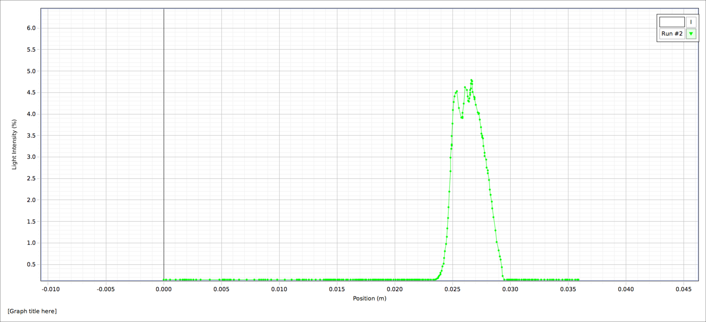

Figure

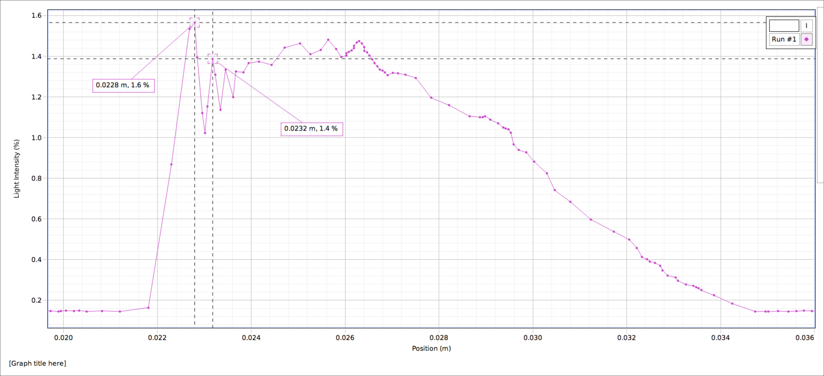

Figure

In the first case, at observation distance of $2.61±0.05m$, I measured the ratio of the intensity of the first interference fringe, $4.5±0.1$, to the intensity in the absence of the plate, $4.6±0.1 \%$, to be $0.98±0.01$, while I predicted this ratio to be approximately $1.35$. This result is not in agreement with the prediction, which I may attribute to the imperfect blocking of the beam with the plate, i.e. not exactly half the beam blocked and plate edge not exactly parallel to sensor slit. I measured the distance between the first two fringe maxima to be $0.07±0.01cm$, which is reasonably close to but not in perfect agreement with the predicted gap of $0.097±0.003cm$.

In the second case, at observation distance of $0.59±0.01m$, I measured the ratio of the intensity of the first interference fringe, $1.60±0.01$, to the intensity in the absence of the plate, $1.50±0.01 \%$, to be $1.07±0.01$, while I again predicted this ratio to be approximately $1.35$. This result is generally close to the prediction. I measured the distance between the first two fringe maxima to be $0.040±0.005cm$, which agrees with the predicted gap of $0.046±0.001cm$. This validated the predictions made by the theory but also illustrated some precision deficiencies in the experimental method.

Arago’s Spot:

In this portion of the experiment, I replaced the blocking plate with a brass disc in a mount so that I could see diffraction in two dimensions. I qualitatively observed the pattern at a variety of screen-brass disc distances, and took special care to note the presence of a bright spot, Arago’s spot, at the center of the shadow of the disc.

I first observed the shadow at a screen-disc distance of $4.00±0.05cm$ as shown in figure 3. No spot was observed, and the shadow looked solid with not much happening inside it.

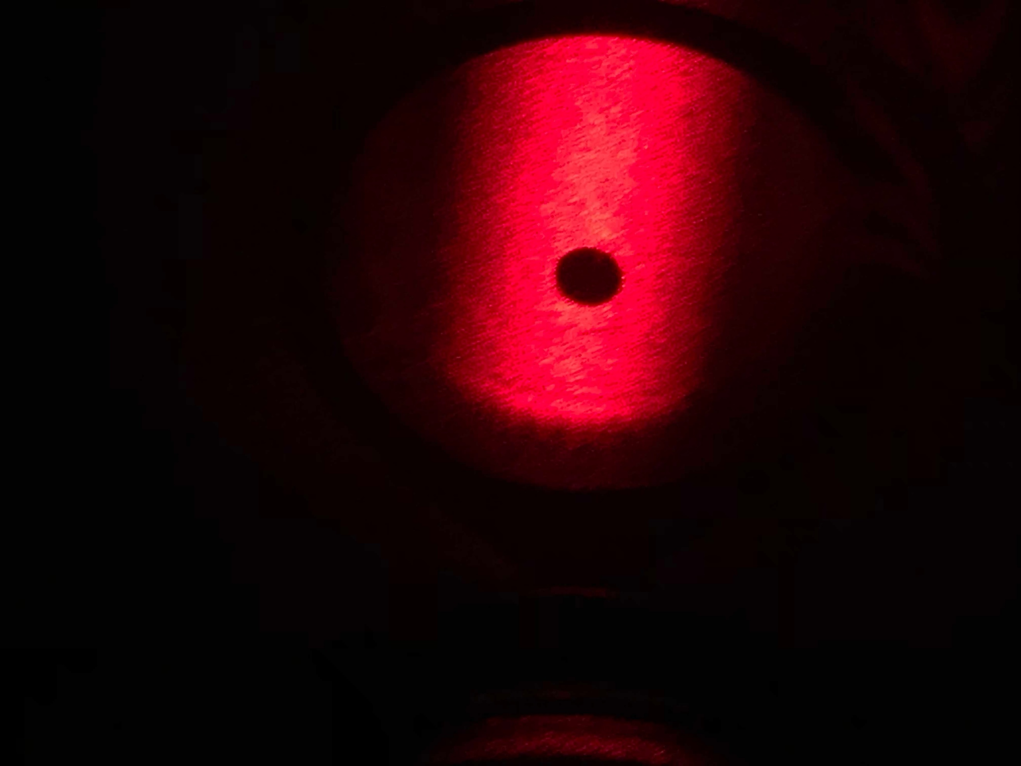

Figure

I then observed the shadow at a distance of $16±1cm$, as shown in figure 4. I did see the spot at this distance and I also saw a strange line inside the shadow.

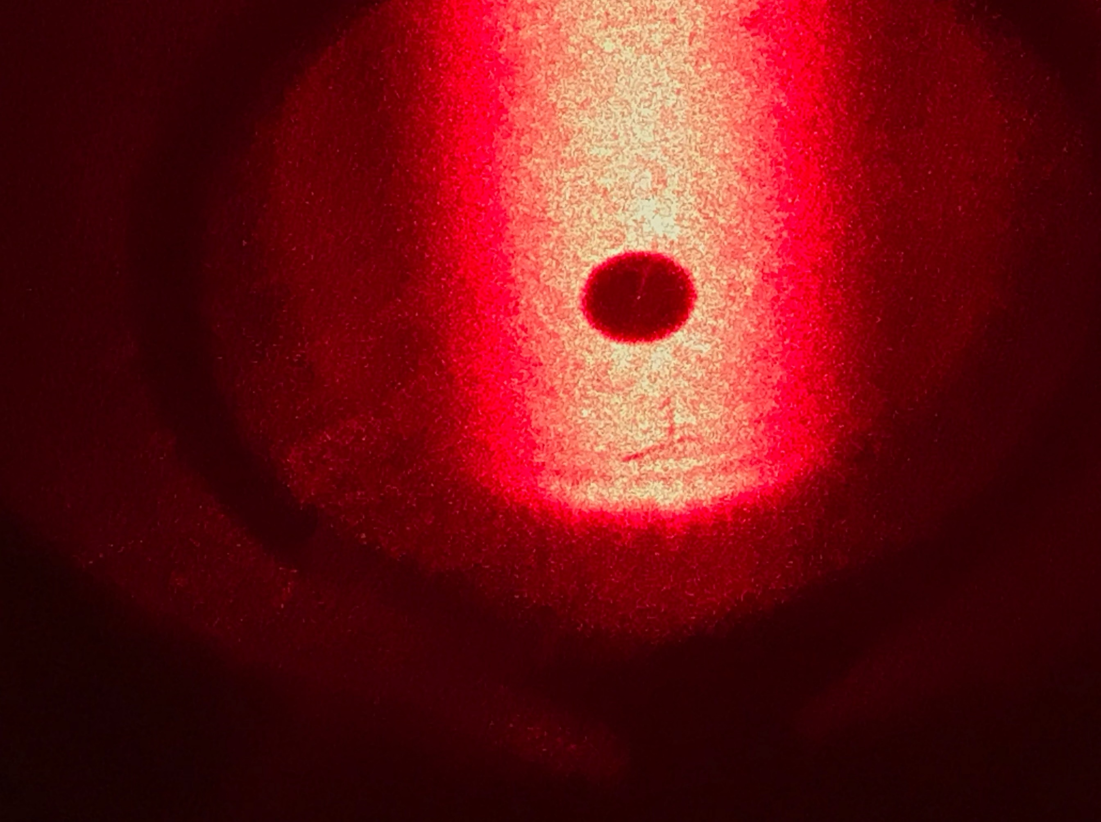

Figure

Next, I observed the shadow at a distance of $60±2cm$, as shown in figure 5. I observed both the spot and several fine lines inside the shadow. Also, more fuzziness was present around the edges of the shadow, artifacts of diffraction.

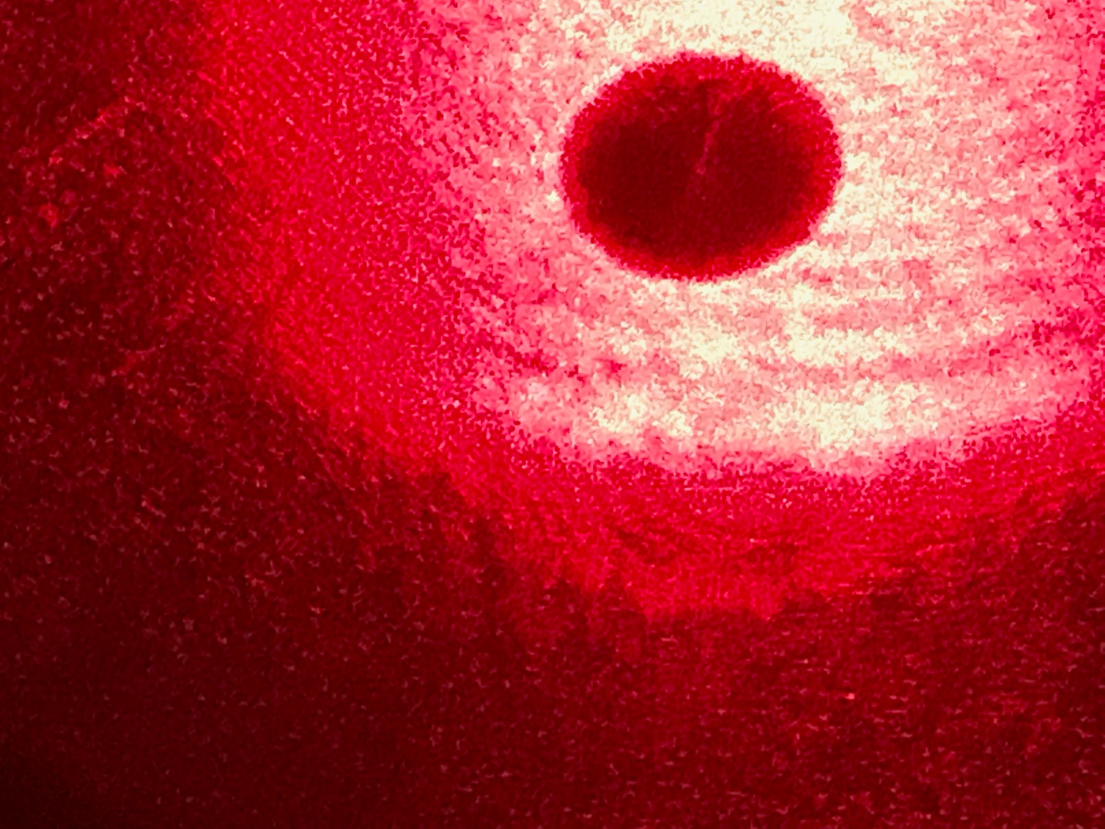

Figure

Lastly, I observed the shadow at a distance of $200±5cm$, as seen in figure 6. I observed the spot, although it was harder to see since there were many iris-like patterns inside the shadow. The camera did not capture the spot, but it was visible to the eye.

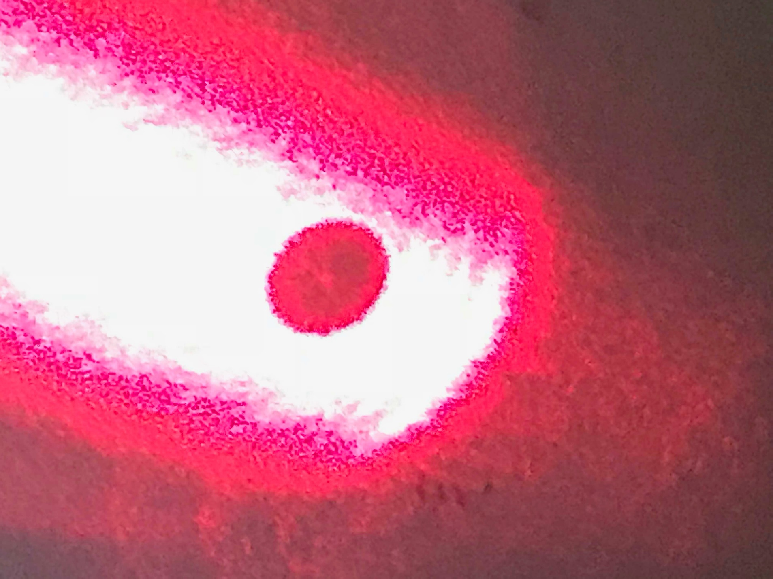

Figure

The Arago spot does not seem to be visible at very close distances (on order of 5cm) but it is observed at greater distances. The structures seen in the shadow probably come from imperfect symmetry of the blocking disc, leading to some constructive interference where there should be only shadow. One possible explanation for this two-dimensional diffraction using the particle nature of light could be that the photons are absorbed by the wall and re-emitted, but not directly backwards, leading to diffraction.

SUMMARY

I successfully measured the wavelength of the laser beam while studying the diffractive behavior of light waves through gratings in this experiment. I also succeeded in confirming much of the theory predicting diffraction angles, albeit with some degree of uncertainty. I then was able to verify the Fresnel diffraction of light past a semi-infinite wall. I was able to confirm the predictions for the amplitudes and spacing of the resulting interference pattern. Additionally, I was able to observe two-dimensional diffraction in the case of light being blocked by a circular disc. I was able to witness Arago’s spot in certain conditions in this diffraction. In doing so, I was able to fulfill each of the objectives outlined in the introduction. A question for a future experiment could be how light could be practically focused, if at all, at the Arago spot using the constructive interference property of the geometry of the blocking object.